IcfaiTech, Hyderabad has proven its eminence among the premier universities of the country by achieving better placements due to its industry-linked curriculum and programs. Adhering to the placement policy, the Placement Cell constantly reinvents & upgrades its practices for effective interaction with industry, and the creation of synergy by building the bridge between academia and industry. This has been achieved through constant collaboration with the industry through seminars, internship courses conducted in industries, research projects, and on and off-campus initiatives.

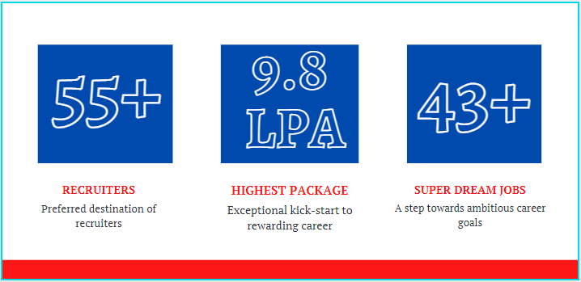

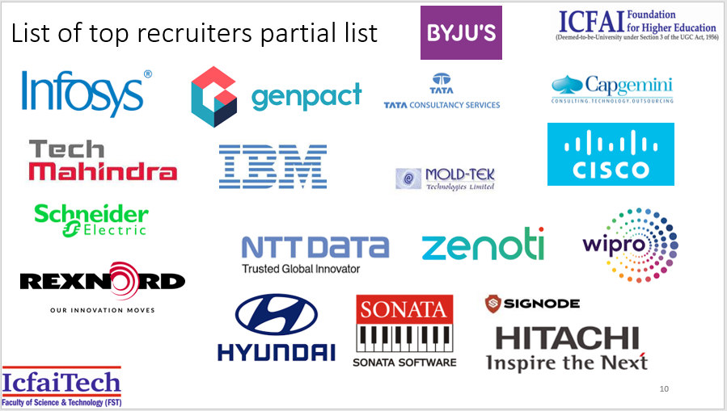
Star Performers
Shafaque Ahmareen, a 2019 B.Tech graduate of ICFAI Tech, Hyderabad, IFHE is recruited by the Ministry of Education, the United Arab Emirates for the position of Junior Researcher in the Department of Internet of Things (IoT) with an annual package of 1,92,000 Dirhams (Rs.36 lakh). Her internship and Special project at IcfaiTech, along with the beneficial curriculum and training provided by IcfaiTech helped her bag this prestigious offer.
Karthik Sai RadhaKrishna and Mani Chandra TejaGaddam received offers as BlockChain Applications Lead Developers from Nvest Global Enterprises Inc., Bengaluru with an annual package of Rs.7.5 lakh. The broad-based curriculum, Internship Program, and Special Projects enabled them to achieve expertise in BlockChain Technology which eventually facilitated them to succeed in the campus placement drive. Karthik says, “The exposure gained from short-term internships, projects, and long term internships which are a part of the curriculum helped a lot in understanding concepts, enhancing skills, and becoming industry-ready”.

